**UNIT IV**

**4.1 CHARTING YOUR DATA**

* **Charts** allow you to illustrate your workbook data **graphically,** which make it easy to visualize **comparisons** and **trends**.

**4.1.1 CREATING CHARTS**

1. Select the **cells** you want to chart, including the **column titles** and **row labels**. These cells will be the **source data** for the chart. In our example, we'll select cells A1:F6.

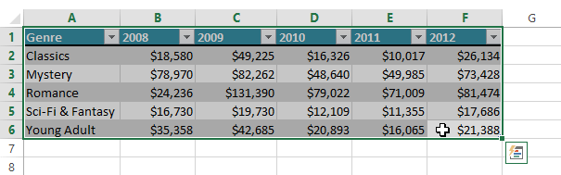

1. From the **Insert** tab, click the desired **Chart** command. In our example, we'll select **Column**.

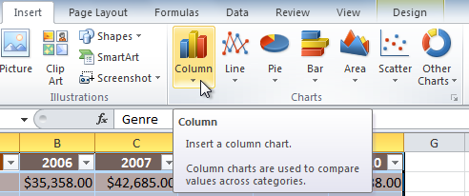

1. Choose the desired **chart** **type** from the drop-down menu.

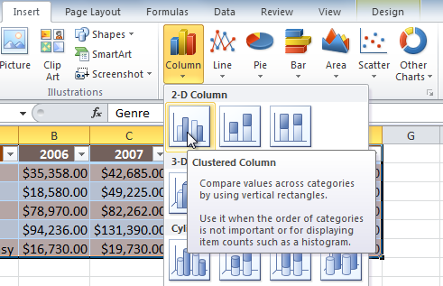

1. The selected chart will be inserted in the worksheet.

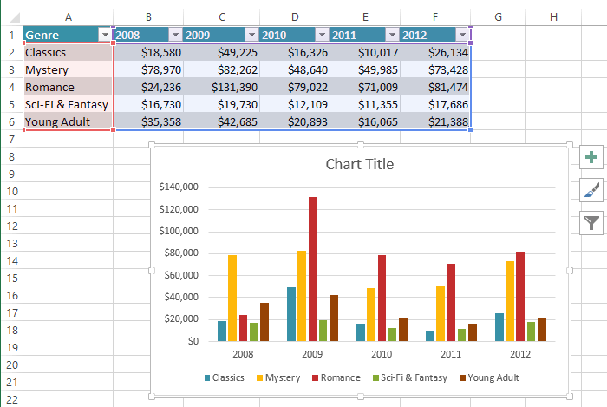

### 4.2 MODIFYING YOUR DATA

* Once you insert a chart, a set of **chart tools** arranged into three tabs will appear on the Ribbon. These are only visible when the chart is selected. You can use these three tabs to **modify** your chart.

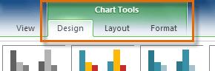

### 4.2.1 CHANGING CHART TYPES

* Excel has several different **types** **of** **charts**, allowing you to choose the one that best fits your data. In order to use charts effectively, you'll need to understand how different charts are used.

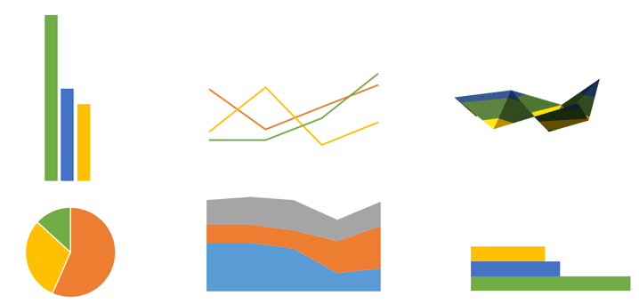

***Types of Charts***

1. From the **Design** tab, click the **Change Chart Type** command. A dialog box appears.

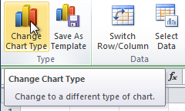

1. Select the desired **chart type**, then click **OK**.

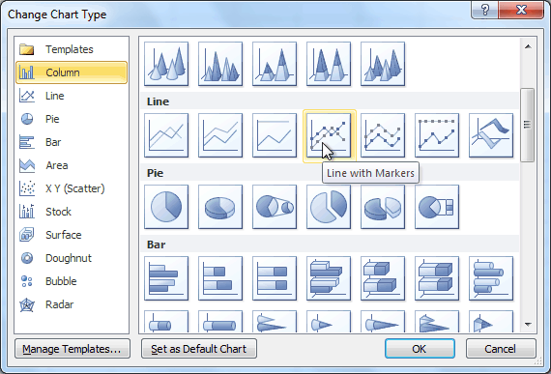

**4.2.2 ENHANCING CHARTS**

#### To switch row and column data

* Sometimes when you create a chart, the data may not be grouped the way you want.
* In the **clustered column chart** below, the Book Sales statistics are grouped **by Fiction and Non-Fiction**, with a column for each year.
* However, you can also **switch the row and column data** so the chart will group the statistics **by year**, with columns for Fiction and Non-Fiction. In both cases, the chart contains the **same data**—it's just organized differently.

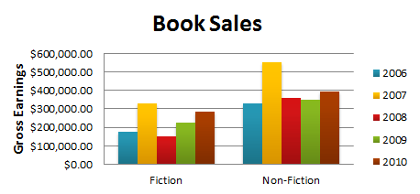

1. Select the **chart**.
2. From the **Design** tab, select the **Switch Row/Column** command.

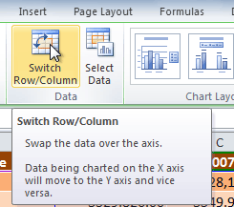

1. The chart will readjust.

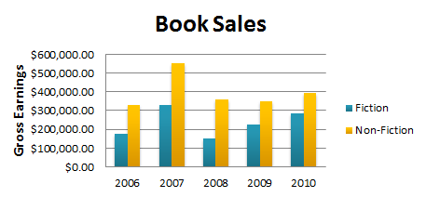

#### To change chart layout

1. Select the **Design** tab.
2. Click the **More** drop-down arrow in the **Chart Layouts** group to see all of the available layouts.

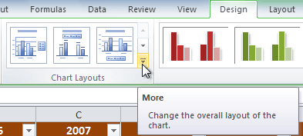

1. Select the desired layout.

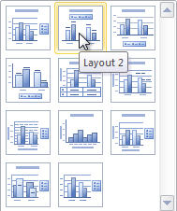

1. The chart will update to reflect the new layout.

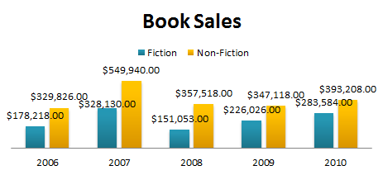

* Some layouts include **chart titles**, **axes**, or **legend labels**. To change them, place the **insertion point** in the text and begin typing.

#### To change chart style:

1. Select the **Design** tab.
2. Click the **More** drop-down arrow in the **Chart Styles** group to see all of the available styles.

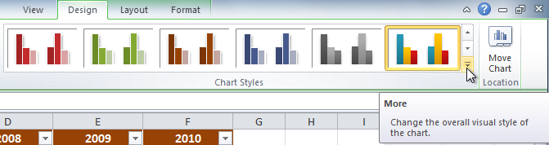

1. Select the desired style.

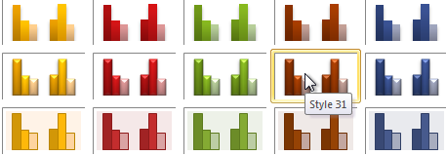

1. The chart will update to reflect the new style.

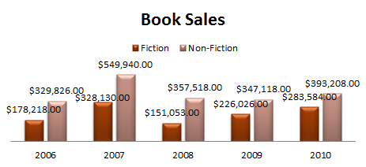

#### To move the chart to a different worksheet:

1. Select the **Design** tab.
2. Click the **Move Chart** command. A dialog box appears. The current location of the chart is selected.

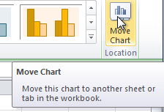

1. Select the desired location for the chart (choose an existing worksheet, or select New Sheet and name it).

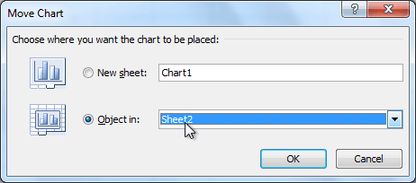

1. Click **OK**. The chart will appear in the new location.

**4.2.3 FORMATTING CHARTS**

* Click on your chart to select it, and then click the **Format** menu at the top of the Excel Ribbon.



* **Shape Styles**

1. First, click on your chart to highlight it
2. Click the **Format** menu on the Excel Ribbon
3. Locate the **Shape Styles** panel:

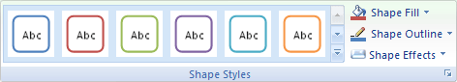

1. Click the down arrow on the right of the panel to see the available styles

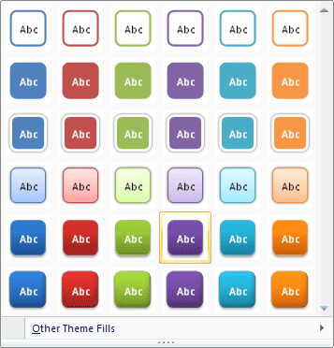

1. When you move your mouse over a style, your chart will change automatically.
2. Fill your chart with a colour by clicking the down arrow on **Shape Fill** on the Shape Styles panel:

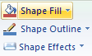

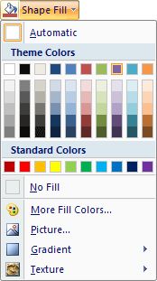

1. Select a colour from the list. Or click "More Fill Colors". Once your chart has a colour, you can liven it up a bit. Still on the same menu, click on **Gradient**. The sub menu appears:

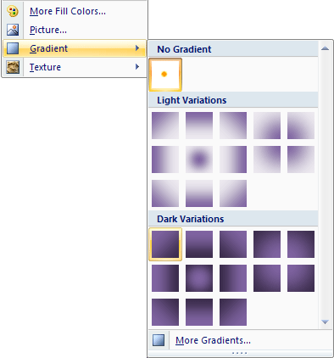

* **WordArt Styles**
* Next, you can spruce up the text on your chart. Locate the **WordArt Styles** panel:

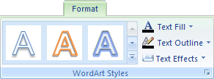

1. Click the **Text Fill** button to see the available colours:

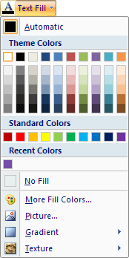

* **Current Selection**
* To bring up the Format Chart Area dialogue box, click the **Format Selection** button on the **Current Selection** panel:

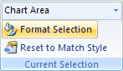

* You'll then see the following dialogue box appear

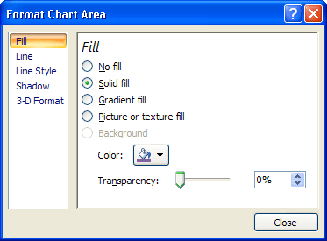

* To get rounded corners, click on **Line** in Excel 2007. You'll then see the following options:

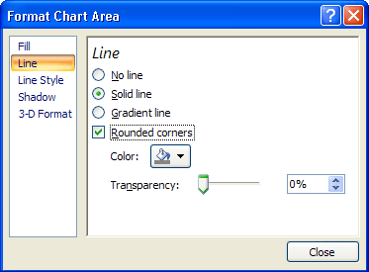

* Put a tick in the box for Rounded Corners.
* To get a Shadow for your chart, click the Shadow option on the left of your dialogue box. The options will change to these:

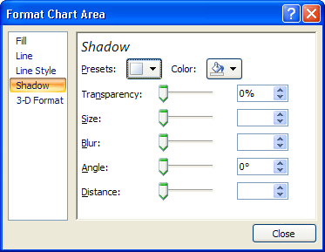

* Click the Presets button to see a list of pre-made shadows:

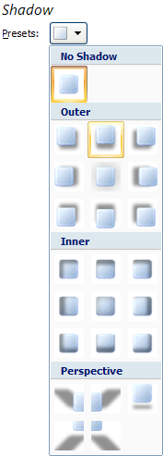

* Select the one you like. Then click Close on the dialogue box. Your chart will then have rounded corners and a drop shadow.

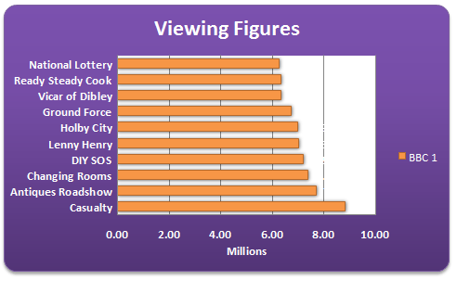

**4.3 PRINTING WORKSHEET AND CHARTS**

#### 4.3.1 PREVIEWING YOUR WORKSHEET

1. Left-click the **Microsoft Office button**.
2. Select **Print**.
3. Select **Print Preview**. The spreadsheet will appear in Print Preview view.

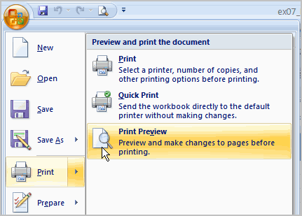

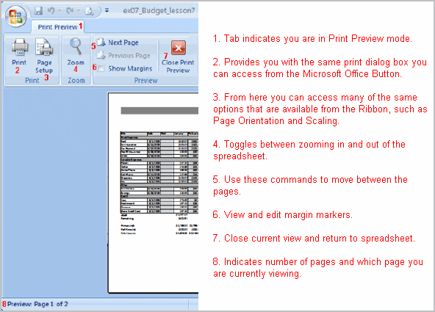

1. Click the **Close Print Preview** button Close Print Previewto return to the Normal View.

#### 4.3.2 SETTING UP PAGES

#### To modify margins:

* Select the **Page Layout** tab.
* Left-click the **Margins** command.
* Choose one of the pre-defined settings, or enter custom margins.

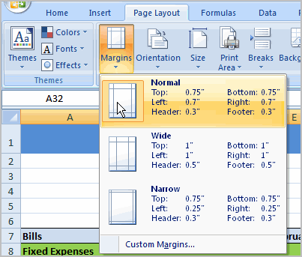

#### To change page orientation:

* Select the **Page Layout** tab.
* Left-click the **Orientation** command.
* Select either Portrait or Landscape.

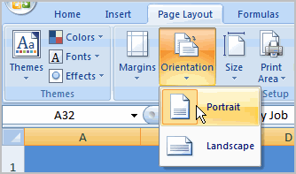

* **Portrait** orients the page **vertically**, while **Landscape** orients the page **horizontally**.

#### To use Scale to Fit:

* Select the **Page Layout** tab.
* Locate the Scale to Fit group.
* Enter a specific **height** and **width**, or use the percentage field to decrease the spreadsheet by a specific percent.

#### To change the paper size:

* Select the **Page Layout** tab.
* Click the **Size** command.
* Select a size option from the list.

#### To define a print area:

* Left-click, then drag your mouse to **select the cells** you wish to print.
* Click the **Print Area** command.
* Choose **Set Print Area**.

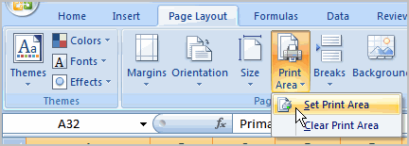

* Now, only the selected cells will print. You can confirm this by viewing the spreadsheet in Print Preview.
* To return to the default setting, which is the entire worksheet, click the Print Area command, then select Clear Print Area.

#### To insert a break:

* Select a cell **below** where you want the break to appear.
* Select the **Breaks** command.
* Select **Insert Break**.

Click Print Preview to confirm that the break appears in the correct place in your spreadsheet.

#### To use the Print Titles command:

* This is an important command to be familiar with if you intend to print your worksheets. It allows you to select **specific rows** and/or **columns** that will be repeated on **each** printed sheet.
* Imagine how difficult it would be to read page 48 of a printed spreadsheet if the column and row headings only appeared on the first page.
* Select the **Page Layout** tab.
* Click the **Print Titles** command. The Page Setup dialog box appears.
* Click the icon at the end of the field.

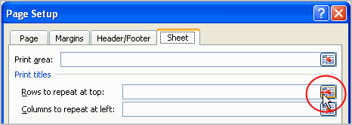

* Select the first row in the spreadsheet that you want to appear on **each printed page**.

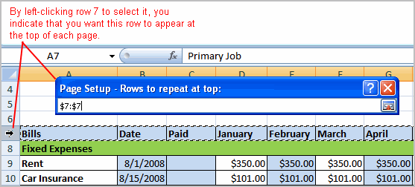

* Repeat for the column, if necessary.
* Click OK.
* **Adding Headers and Footers.**
* Select the **Page Layout** tab.
* Click the **Print Titles** command. The Page Setup dialog box appears.
* Select **Headers and Footers** tab.

Type Headers and Footers**, Headers and Footers** then click OK button.

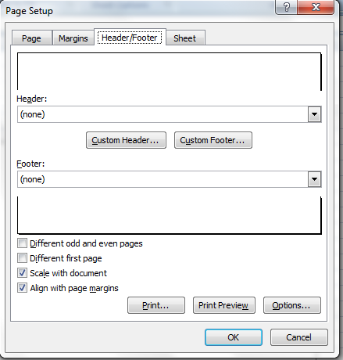r

#### To print from the Microsoft Office button:

* Left-click the **Microsoft Office button**.
* Select **PrintactionPrint**. The Print dialog box appears.

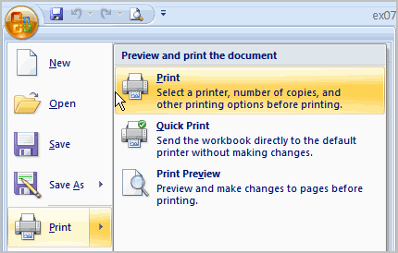

* Select a printer if you wish to use a printer other than the default setting.
* Click **Properties** to change any necessary settings.
* Choose whether you want to print specific pages, all of the worksheet, a selected area, the active sheet, or the entire workbook.
* Select the number of copies you'd like to print.
* Click **OK**.